J.R. MURPHY
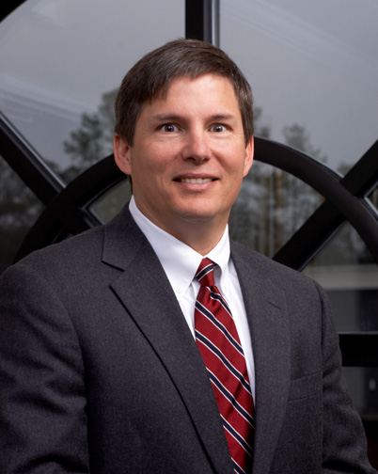
Shareholder
Email: jrmurphy@murphygrantland.com
Phone: 803-782-4100 ext. 1231; Direct Dial 454-1231
Fax: 803-782-4140

J.R. is one of the founding partners of the firm along with John Grantland

Practice Areas
Coverage and Bad Faith actions, Premises and Products liability, Construction Defects, Defense of Serious Bodily Injury claims

Education
- University of South Carolina, B.S.
- University of South Carolina, Juris Doctor

Admissions
- South Carolina Bar
- U.S. District Court for the District of South Carolina
- U.S. Supreme Court
- U.S. Court of Appeals for Fourth Circuit

Memberships/Associations
- Richland County Bar Association
- Former member of the Circuit Court Committee
- South Carolina Bar Association
- Member of Torts and Insurance Practice, Alternative Dispute Resolution, Construction and Employment Law Sections
- Editorial Board –Law of Automobile Insurance in South Carolina, Third Edition
- South Carolina Defense Trial Attorneys Association
- Defense Research Institute
- South Carolina Insurance Fraud Investigators
- Lecturer at CLE and insurance industry seminars around the country

REPORTED CASES

Campbell, Inc. v. Northern Ins. Co. of New York, 337 F.Supp.2d 764 (D.S.C. 2004); Charleston Dry Cleaners & Laundry, Inc. v. Zurich American Ins. Co., 355 S.C. 614, 586 S.E.2d 586 (2003); Century Ind. Co. v. Stoltz, et al., 348 S.C. 559, 561 S.E.2d 355 (2002); Mixson, Inc. v. American Loyalty Ins. Co., 349 S.C. 394, 562 S.E.2d 659 (S.C. App. 2002); Nationwide Mutual Ins. Co. v. Powell, 292 F.3d 201 (4th Cir. 2002); Newton v. Progressive Northwestern Ins. Co., 347 S.C. 271, 554 S.E. 2d 437 (2001); Miletic v. Wal-Mart Stores, Inc., 339 S.C. 327, 529 S.E. 2d 68 (2000); Catawba Ins. Co. v. Smith, 336 S.C. 33, 518 S.E. 2d 291 (1999); Ford v. SCDOT, et.al., 328 S.C. 481, 492 S.E.2d 811 (1997); Pryor v. Northwest Apartments, 321 S.C. 524, 469 S.E.2d 630 (1996); Guide v. Spooner, 318 S.C. 335, 457 S.E.2d 623 (1995); Bailey v. Peacock, 318 S.C. 13, 455 S.E.2d 690 (1995); Chavous v. Brown, (on brief), 305 S.C. 387, 409 S.E.2d 356 (1991); Crowell v. Herring, (on brief) 301 S.C. 424, 392 S.E.2d 464 (S.C. App. 1990)

JOHN M. GRANTLAND

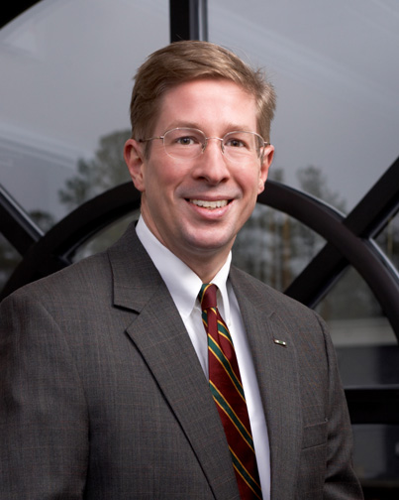
Shareholder
Email: jgrantland@murphygrantland.com
Phone: 803-782-4100 ext. 1237; Direct Dial 454-1237
Fax: 803-782-4140

John is one of the founding partners of the firm along with J.R. Murphy

Former Staff Attorney for Governor Carroll Campbell
Former Captain and Judge Advocate in the U.S. Marine Corps

Practice Areas
Premises Liability, Personal Injury Defense, Automobile Insurance

Education
- The Citadel, B.A., magna cum laude
- Algernon Sydney Sullivan Award
- University of South Carolina, Juris Doctor
- Vice President Student Bar Association

Admissions
- South Carolina Bar
- U.S. District Court for the District of South Carolina
- U.S. Court of Appeals for Fourth Circuit
- U.S. Court of Military Appeals

Memberships/Associations
- Richland County Bar
- South Carolina Defense Trial Attorneys Association
- The Defense Research Institute
- The Council on Ethical Billing
- Chairman of the Midlands Judicial Selection Committee
- Co-authored and published a chapter in South Carolina Jurisprudence
- Lecturer at CLE and insurance industry seminars around the country

RONALD B. DIEGEL

Shareholder
Email: rbdiegel@murphygrantland.com
Phone: 803-782-4100 ext. 1207; Direct Dial 454-1207
Fax: 803-782-4140

Practice Areas
Premises Liability, Automobile and Trucking Law, Insurance Defense

Education
- The Citadel, B.S.
- Regimental Executive Officer and Commander of the Summerall Guards
- President’s Award
- University of South Carolina, Juris Doctor

Admissions
- South Carolina Bar
- U.S. District Court for the District of South Carolina
- U.S. Court of Appeals for Fourth Circuit

Memberships/Associations
- Transportation Lawyers Association
- South Carolina Defense Trial Attorneys Association
- Defense Research Institute
- Richland County Bar Association
- American Board of Trial Advocates

REPORTED CASES

Hancock v. Wal-Mart Stores, Inc., 355 S.C. 168, 584, S.E.2d 398 (S.C. App. 2003).

BRENT M. BOYD

Shareholder
Email: bboyd@murphygrantland.com
Phone: 803-782-4100 ext. 1210; Direct Dial 454-1210
Fax: 803-782-4140

Practice Areas
Construction Defects, Premises Liability, Products Liability, Employment Disputes, Auto and Truck accident defense, General Representation of Contractors, Retail and Restaurant Businesses, and Nursing Homes and Assisted Living Facilities

Education
- University of Virginia, B.A.
- University of South Carolina, Juris Doctor, cum laude
- Editorial Board, South Carolina Law Review
- Order of the Wig and Robe
- Order of the Coif

Admissions
- South Carolina Bar
- U.S. District Court for the District of South Carolina

Memberships/Associations
- Richland County Bar Association
- South Carolina Bar
- South Carolina Defense Trial Attorneys Association
- Defense Research Institute
- National Retail and Restaurant Defense Association
- Council on Litigation Management

E. RAYMOND MOORE, III

Shareholder
Email: ermoore@murphygrantland.com
Phone: 803-782-4100 ext. 1235; Direct Dial 454-1235
Fax: 803-782-4140

Practice Areas
Products Liability, Insurance Defense, Pharmacy Malpractice, Coverage

Education
- The Citadel, B.A., summa cum laude
- First Honor Graduate
- Regimental Commander and Chairman of the Honor Committee
- Presidential Advisory Committee
- University of South Carolina, Juris Doctor, cum laude
- Editorial Board South Carolina Law Review
- Order of the Wig and Robe
- Order of the Coif
- Irving Steinberg Award

Admissions
- South Carolina Bar
- U.S. District Court for District of South Carolina
- U.S. District Court of Appeals for Fourth Circuit
- U.S. Supreme Court

Memberships/Associations
- Richland County Bar Association
- South Carolina Bar
- Defense Research Institute
- South Carolina Defense Trial Attorneys Association
- American Bar Association
- American Society for Pharmacy Law

REPORTED CASES

Atlantic Floor Services, Inc. v. Wal-Mart Stores, Inc., 334 F.Supp.2d 875 (D.S.C. 2004); Bessinger v. Food Lion, Inc., 305 F.Supp.2d 574(D.S.C. 2003); Nationwide Mutual Ins. Co. v. Powell, 292 F.3d 201 (4th Cir. 2002); Westberry v. Gislaved Gummi, AB, 178 F.3d 257 (4th Cir. 1999).

ANTHONY W. LIVOTI
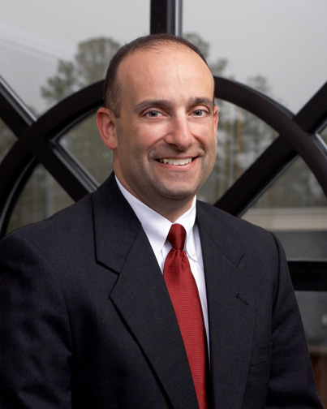
Shareholder
Email: awlivoti@murphygrantland.com
Phone: 803-782-4100 ext. 1209; Direct Dial 454-1209
Fax: 803-782-4140

Practice Areas
Premises Liability, Automobile Law, Coverage Issues, General Insurance Defense, Products Liability, Worker’s Compensation

Education
- The Citadel, B.A.
- University of South Carolina, Juris Doctor, cum laude
- Articles editor South Carolina Law Review
- Order of Wig and Robe
- Order of the Coif

Admissions
- South Carolina Bar
- U.S. District Court for the District of South Carolina
- U.S. Court of Appeals for Fourth Circuit

Memberships/Associations
- Richland County Bar Association
- South Carolina Bar
- South Carolina Defense Trial Attorneys Association
- Executive Board Member
- Defense Research Institute
- Lecturer at CLE seminars
- Four years U.S. Navy Surface Warfare Officer with two overseas deployments


ADAM J. NEIL

Shareholder
Email: aneil@murphygrantland.com
Phone: 803-782-4100 ext. 1232; Direct Dial 454-1232
Fax: 803-782-4140

Former clerk for Honorable Humes J. Franklin, Jr., Virginia Circuit Court

Practice Areas
Insurance Coverage, Bad Faith Defense, Premises and Products Liability, Professional Malpractice

Education
- University of Kentucky, B.B.A., magna cum laude with departmental honors
- Washington and Lee University School of Law, Juris Doctor
- Judge S. Leslie Mestrezat Scholar

Admissions
- South Carolina Bar
- U.S. District Court for the District of South Carolina
- U.S. Court of Appeals for Fourth Circuit

Memberships/Associations
- Richland County Bar Association
- South Carolina Bar Association
- American Bar Association
- Defense Research Institute
- South Carolina Defense Trial Attorneys Association
- Co-Authored Article – Multiple Policies and Defense Cost Allocation in For The Defense

REPORTED CASES

Nationwide Mutual Ins. Co. v. Powell, 93 Fed. Appx. 565 (4th Cir. 2004); Charleston Dry Cleaners & Laundry, Inc. v. Zurich American Ins. Co., 355 S.C. 614, 586 S.E.2d 586 (2003); Generali-US Branch v. American Southern Ins. Co., 280 Fed. Appx. 315, C.A. 4 (S.C.); Generali-US Branch v. American Southern Ins. Co., 269 Fed. Appx.337, C.A.4 (S.C.); Zurich American Ins. Co. v. Sumter Hotel Group Ltd. Partnership, 2007 WL 1191039, D.S.C.; Nationwide Mut. Ins. Co. v. Erwood, 373, S.C. 88,644 S.E.2d 62, S.C.; Floyd v. Nationwide Mut. Ins. Co., 221 Fed. Appx. 207, C.A.4(S.C.); Southern Land and Golf Co. Ltd. v. Harleysville Mut. Ins. Co., WL 2443340, D.S.C.; Pennsylvania Mfrs. Ass’n Ins. Co. v. Dargan Const. Co., 2006 WL2038270, D.S.C.; Harleysville Mut. Ins. Co. v. Cambridge Bldg. Corp, 66 Fed.R.Serv.3d 811, D.S.C.; Bellino v. Scottsdale Ins. Co., Slip Copy, 2006 WL 1129402, D.S.C.; South Carolina Mun. Ins. and Risk Fund v. City of Myrtle Beach, 368 S.C. 240, 628, S.E.2d 276; Floyd v. Nationwide Mut. Ins. Co., 367 S.C. 253, 626 S.E. 2d 6; Jackson v. Swordfish Investments, LLC, 365 S.C. 608, 620 S.E.2d 54, S.C.; Auto-Owners Ins. Co. v. Essex Homes Southeast, Inc., 136 Fed. Appx. 590; Nationwide Mut. Ins. Co. v. Erwood, 364 S.C. 1, 611 S.E.2d 319; Progressive Cas. Ins. Co. v. Leachman, 362 S.C. 344, 608 S.E.2d 569, S.C.; Nationwide Mutual Ins. Co. v. Powell, 93 Fed. Appx. 565, C.A.4 (S.C.); Charleston Dry Cleaners & Laundry, Inc. v. Zurich American Ins. Co., 355 S.C. 614, 586 S.E.2d 586, 2003, S.C.

CHARLES G. BLACKBURN
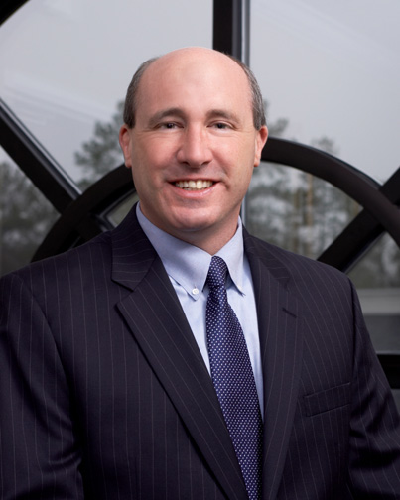
Shareholder
Email: cblackburn@murphygrantland.com
Phone: 803-782-4100 ext. 1208; Direct Dial 454-1208
Fax: 803-782-4140

Practice Areas
Construction and Environmental Law

Education
- College of Charleston, B.S.
- University of Tennessee, M.S.
- University of South Carolina, Juris Doctor

Admissions
- South Carolina Bar
- U.S. District Court for the District of South Carolina

Memberships/Associations
- Richland County Bar Association
- Lexington County Bar Association
- South Carolina Bar Association
- General Counsel – South Carolina Ground Water Association
- National Groundwater Association

JEFFREY C. KULL
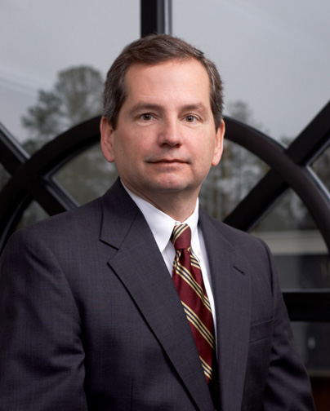
Of Counsel
Email: jkull@murphygrantland.com
Phone: 803-782-4100 ext. 1243; Direct Dial 454-1243
Fax: 803-782-4140

Former clerk for Honorable Randall T. Bell, S.C. Court of Appeals
Former clerk for Honorable Dennis W. Shedd, U.S. District Court and
U.S. Court of Appeals for Fourth Circuit

Practice Areas
Coverage Issues, General Insurance Defense

Education
- Liberty University, B.S.
- University of South Carolina, Juris Doctor
- Editor in Chief of ABA Real Property, Probate & Trust Journal
- Order of the Coif
- Order of Wig and Robe

Admissions
- South Carolina Bar
- Illinois Bar

ALICE PRICE ADAMS

Of Counsel
Email: aadams@murphygrantland.com
Phone: 803-782-4100 ext. 1244; Direct Dial 454-1244
Fax: 803-782-4140

Practice Areas
Worker’s Compensation, Premises Liability, Automobile Law, General Insurance Defense

Education
- Clemson University, B.A., magna cum laude
- University of South Carolina, Juris Doctor
- Associate Justice of Moot Court
- Captain of ABA Moot Court Team

Admissions
- South Carolina Bar

Memberships/Associations
- Richland County Bar Association
- South Carolina Bar Association
- Co-author Hospital Law section of South Carolina Jurisprudence
- South Carolina Workers’ Compensation Educational Association

WILLIAM H. FRYE


Of Counsel
Email: wfrye@murphygrantland.com
Phone: 803-782-4100 ext. 1233; Direct Dial 454-1233
Fax: 803-782-4140

Practice Areas
Insurance Coverage Analysis, Litigation, Appellate Law

Education
- University of South Carolina
- University of Memphis School of Law

Admissions
- South Carolina Bar
- Tennessee Bar
- U.S. District Court for the District of South Carolina
- U.S. District Court for the Western District of Tennessee

Memberships/Associations
- Richland County Bar Association
- South Carolina Bar Association

PETER E. FARR

Associate
Email: pfarr@murphygrantland.com
Phone: 803-782-4100 ext. 1234; Direct Dial 803-454-1234
Fax: 803-782-4140

Practice Areas
Insurance Coverage, Premises Liability, Personal Injury Defense, Property Damage, Fraud, Church Liability

Education
- Bob Jones University, B.S., cum laude
- University of South Carolina, Juris Doctor
- Merit Scholar
- Articles editor for South Carolina Law Review
- Panelist at National Conference of Law Reviews
- Research assistant for Professor Bill Quirk

Admissions
- South Carolina Bar
- U.S. District Court for the District of South Carolina
- U.S. District Court of Appeals for Fourth Circuit

Memberships/Associations
- South Carolina Bar
- Richland County Bar
- Defense Research Institute
- South Carolina Defense Trial Attorneys Association

.

TIMOTHY J. NEWTON

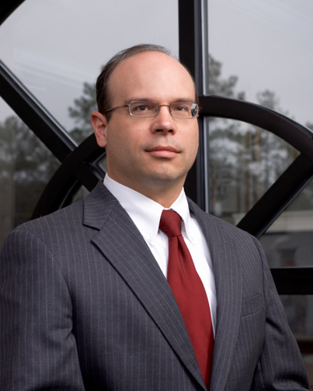
Associate
Email: tnewton@murphygrantland.com
Phone: 803-782-4100 ext. 1242; Direct Dial 454-1242
Fax: 803-782-4140

Former Staff Attorney for South Carolina Court of Appeals
Former Clerk for Honorable John W. Kittredge, S.C. Court of Appeals

Practice Areas
Insurance Coverage, Construction, Premises Liability, Auto Defense, Appeals

Education
- Louisiana State University, B.A.
- Wayne State University, M.A.
- University of South Carolina, Juris Doctor
- Research editor – South Carolina Law Review
- Order of the Wig and Robe
- Order of the Coif

Admissions
- South Carolina Bar
- U.S. District Court for the District of South Carolina

Memberships/Associations
- Richland County Bar Association

CHRISTOPHER A. MAJURE


Associate
Email: cmajure@murphygrantland.com
Phone: 803-782-4100 ext. 1295
Fax: 803-782-4140

Former Law Clerk for Securities Division of the Office of Attorney General for S.C.

Practice Areas
Construction Defect Defense Litigation, Personal Injury, Mechanic’s Lien

Education
- Erskine College
- President Phi Lambda Sigma
- University of South Carolina, Juris Doctor

Admissions
- South Carolina Bar

Memberships/Associations
- U.S. Navy
- Communications Officer
- Gunnery and Ordnance Officer
- Training Officer for Naval Military Police

ASHLEY B. STRATTON

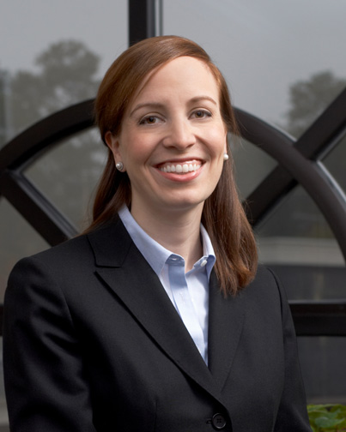
Associate
Email: astratton@murphygrantland.com
Phone: 803-782-4100 ext. 1241
Fax: 803-782-4140

Former clerk for Honorable E.C. Burnett, III, S.C. Supreme Court

Practice Areas
Insurance Coverage

Education
- University of South Carolina, Honors College, B.A., magna cum laude
- Wake Forest University School of Law, Juris Doctor
- Member Moot Court

Admissions
- South Carolina Bar

Memberships/Associations
- Richland County Bar Association
- South Carolina Bar Association

